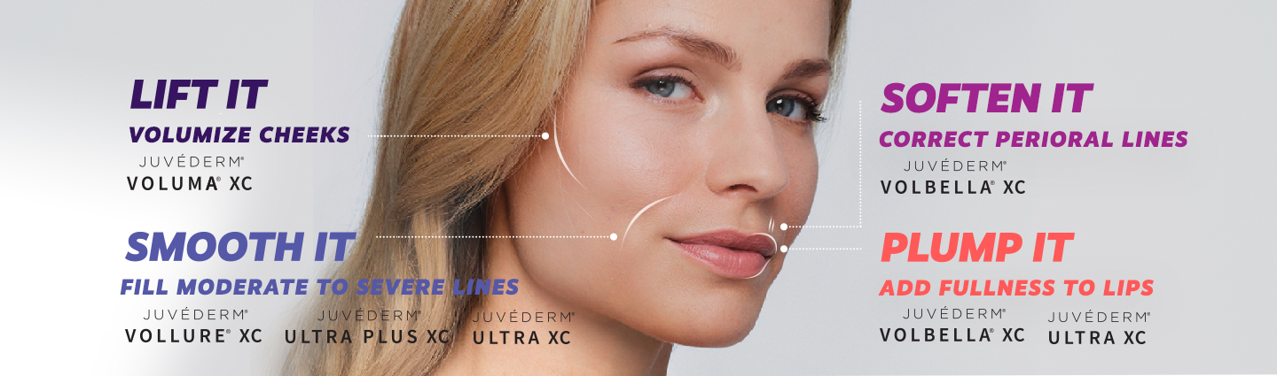
Dr. Claudia Piccolo
“As a member of the American Academy of Facial Esthetics, we create beautiful faces every single day. We are dedicated to providing the most advanced minimally invasive non-surgical techniques for beautiful facial esthetics.
Millions of people use Botox®, and Juvederm® to achieve a more relaxed and smooth facial appearance while still having freedom of expression. Combine this with teeth whitening and porcelain veneers, and you will quickly have a much more youthful appearance.”

